**HUNTERS SIGHT IN**

**MOLALLA RIFLE CLUB**

**September 21,22 & 28,29**

**9:00 am – 6:00 pm**

**Suggested $5 donation per gun**

**Ear and eye protection required**

DIRECTIONS & MAP TO THE RANGE:

From Hwy 211 in Colton, OR turn south on Wall St (at the Colton Market). At Green Mtn Rd turn east (left), go to Grays Hill Rd and turn south (right), at the top of the hill turn east (left) on Hunter Rd. When the pavement ends continue on gravel road approx. 1/2 mile, our gate is on 3rd road on the right. The gate will be open. The range is located on leased BLM land surrounded by private timberland about 1.5 miles behind the gate.

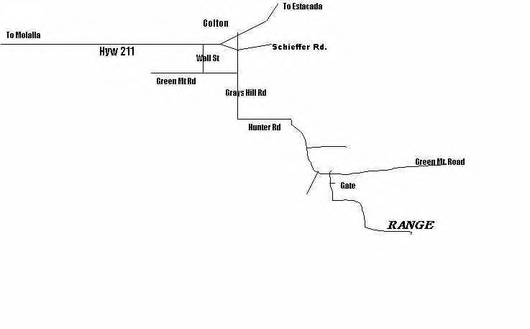Website: [**www.molallarifleclub.org**](http://www.molallarifleclub.org) **Email:** [**mrc@molallarifleclub.org**](mailto:mrc@molallarifleclub.org)